Project Report:



HOSPITAL MANAGEMENT SYSTEM IN C PROGRAMMING

**Submitted to: Sir Shahroz Bakht**

**By:**

**M.Mubbashir Shakeel**

**(SP20-BSSC-0084)**

TABLE OF CONTENT

|  |  |
| --- | --- |
| Topic | Page |
| 1. Introduction………………………………………… 2. Source Code ………………………………………… 3. Algorithm……………………………………………. 4. Results ………………………………………………… | 3  5  71  73 |

Introduction:

As long as each stage implementation needs to be accurate and explicit, the Hospital management system provides certain automation of many vital daily processes. The hospital system software covers the services that unify and simplify the work of healthcare professionals as well as their interactions with patients.

There is always the wide choice of features that can be included in the system. Moreover, the most important thing they are created to streamline various procedures that meet the needs of all the users. The hospital management system feature list is concentrated on providing the smooth experience of patients, staff and hospital authorities. It might seem that their expectations differ; they still are covered by components of the hospital information system. Quality and security still remain the main criteria of the medical industry. It is also known for the constant and rapid changes to improve the efficiency of medical services and satisfaction of the patients.

So we make a Hospital management system that is written in C- Language, which is the mother of all languages. Since the purpose of the hospital information system is the arrangement of necessary, precise and appropriate data, the hospitals should ensure the system work and can be accessed at any time. This could be a unique system for the certain institution, chain of clinics, state hospitals or even the international medical organizations.

Source Code:

#include<stdio.h>//Use for standard I/O Operation

#include<windows.h>//example is gotoxy

#include<conio.h>//Use for delay(),getch(),gotoxy(),etc.

#include<ctype.h>//se for toupper(), tolower(),etc

#include<string.h>//Use for strcmp(),strcpy(),strlen(),etc

#include<stdlib.h>

char ans=0;//To yes or no

int ok;

int b;

int valid=0;//for check valid or not

//Function Prototype

void FrontScreen();//prototype of frontscreen function

void Header();//prototype of Header function

void Menu();//prototype of Menu function

void LoginScreen();//prototype of Loginscreen function

void Add_rec();//prototype of add patient record function

void list();//prototype of list patient record function

void Search();//prototype of search patient record function

void Edit();//prototype of edit patient record function

void Dlt();//prototype of delete patient record function

void exit();//prototype of exit from program

void maximizeWindow(){ //for maximize the screen

HWND hwnd = GetConsoleWindow();

ShowWindow(hwnd, SW_SHOWMAXIMIZED);

}

void gotoxy(short x, short y) {//to select place any

COORD pos = {x, y};//sets co-ordinates in (x,y).

SetConsoleCursorPosition(GetStdHandle(STD_OUTPUT_HANDLE), pos);

}

struct Patient_Information//global variable

{

int S_No=1;

char First_Name[15];

char Last_Name[15];

int age;

char Gender;

char Address[30];

char Contact_No[15];

char Email[30];

int Patient_Problem;

int Doctor_Name;

};

struct Patient_Information patient,temp;

int main()

{

FrontScreen();

Header();

LoginScreen();

}

void FrontScreen() //function for front welcome screen

{

maximizeWindow();

printf("\n\n\n\n\n\n\n\n\n\n\n\n\n\n\n\n\n\n\t\t\t\t\t\t\t@@@@@@@@@@@@@@@@@@@@@@@@@@@@@@@@@@@@@@@@@@@@@@@@@@@@@@@@@@@@@@@@@@@@@@@@@@@@@@@@@@@@@@@@@@@@@\n");

printf("\t\t\t\t\t\t\t@@ _______________________________________________________________________________________ @@\n");

printf("\t\t\t\t\t\t\t@@| |@@\n");

printf("\t\t\t\t\t\t\t@@| |@@\n");

printf("\t\t\t\t\t\t\t@@| |@@\n");

printf("\t\t\t\t\t\t\t@@| |@@\n");

printf("\t\t\t\t\t\t\t@@| |@@\n");

printf("\t\t\t\t\t\t\t@@| |@@\n");

printf("\t\t\t\t\t\t\t@@| WELCOME TO |@@\n");

printf("\t\t\t\t\t\t\t@@| |@@\n");

printf("\t\t\t\t\t\t\t@@| HOSPITAL MANAGEMENT SYSTEM |@@\n");

printf("\t\t\t\t\t\t\t@@| |@@\n");

printf("\t\t\t\t\t\t\t@@| |@@\n");

printf("\t\t\t\t\t\t\t@@| |@@\n");

printf("\t\t\t\t\t\t\t@@| |@@\n");

printf("\t\t\t\t\t\t\t@@| |@@\n");

printf("\t\t\t\t\t\t\t@@| |@@\n");

printf("\t\t\t\t\t\t\t@@|_______________________________________________________________________________________|@@\n");

printf("\t\t\t\t\t\t\t@@@@@@@@@@@@@@@@@@@@@@@@@@@@@@@@@@@@@@@@@@@@@@@@@@@@@@@@@@@@@@@@@@@@@@@@@@@@@@@@@@@@@@@@@@@@@\n\n\n\n\t\t\t\t\t");

printf("\n\n\n\n\n Enter any key to continue......\n");

getch();//Use to holds screen for some seconds

system("cls");//Use to clear screen

}

void Header()//function for Header screen

{

printf("\n\n\n\n\n\n\n\n\n\n\n\n\n\n\n\n\n\n\t\t\t\t\t\t\t@@@@@@@@@@@@@@@@@@@@@@@@@@@@@@@@@@@@@@@@@@@@@@@@@@@@@@@@@@@@@@@@@@@@@@@@@@@@@@@@@@@@@@@@@@@@@\n");

printf("\t\t\t\t\t\t\t@@ _______________________________________________________________________________________ @@\n");

printf("\t\t\t\t\t\t\t@@| |@@\n");

printf("\t\t\t\t\t\t\t@@| |@@\n");

printf("\t\t\t\t\t\t\t@@| WELCOME TO |@@\n");

printf("\t\t\t\t\t\t\t@@| |@@\n");

printf("\t\t\t\t\t\t\t@@| HOSPITAL MANAGEMENT SYSTEM |@@\n");

printf("\t\t\t\t\t\t\t@@| |@@\n");

printf("\t\t\t\t\t\t\t@@| |@@\n");

printf("\t\t\t\t\t\t\t@@|_______________________________________________________________________________________|@@\n");

printf("\t\t\t\t\t\t\t@@@@@@@@@@@@@@@@@@@@@@@@@@@@@@@@@@@@@@@@@@@@@@@@@@@@@@@@@@@@@@@@@@@@@@@@@@@@@@@@@@@@@@@@@@@@@\n\n\n\n\t\t\t\t\t");

}

void Menu()//function decleration

{

system("cls");//use to clear screen

int x;

Header();// call Header function

printf("\n\n\n\n\n\t\t\t\t\t\t\t1. Add Patients Record\n");

printf("\n\t\t\t\t\t\t\t2. List Patients Record\n");

printf("\n\t\t\t\t\t\t\t3. Search Patients Record\n");

printf("\n\t\t\t\t\t\t\t4. Edit Patients Record\n");

printf("\n\t\t\t\t\t\t\t5. Delete Patients Record\n");

printf("\n\t\t\t\t\t\t\t6. Exit\n");

printf("\n\n\n \n\t\t\t\t\t\t\tChoose any one 1 to 6:");

scanf("%i", &x);

switch(x)//switch to differeht case

{

case 1:

Add_rec();//Add_rec function is called

break;

case 2:

list();//list function is called

break;

case 3:

Search();

break;

case 4:

Edit();

break;

case 5:

Dlt();

break;

case 6:

exit();

break;

default:

printf("\t\t\tPlease Enter Right Value :)");

getch();//holds screen

}//end of switch

}

void LoginScreen()//function for login screen

{

//list of variables

int count=0; //for count to check how much time login

char Username[15];

char Password[15];

char Output_Username[25]="admin";

char Output_Password[15]="12345";

int i =0;

char ch;

do

{

printf("\n\n\n\n\t\t\t\tEnter your Username and Password :)");

printf("\n\n\n\t\t\t\t\tUSERNAME:");

scanf("%s",&Username);

printf("\n\n\t\t\t\t\tPASSWORD:");

while(1)

{

ch=getch();

if(ch==13)

{

Password[i]='\0';

break;

}

else if(ch== 8)

{

if(i>0)

{

i--;

printf("\b \b");

}

}

else if(ch==9||ch==32)

{

continue;

}

else

{

Password[i]=ch;

i++;

printf("*");

}

}

if (strcmp(Username,Output_Username)==0 && strcmp(Password,Output_Password)==0)//strcmp to compare two variable to check the username and passwod

{

printf("\n\n\n\t\t\t\t\t...Login Successfull...");

getch();

Menu();//call Menu function

break;

}

else

{

printf("\n\n\n\n\t\t\tPassword in incorrect:( Try Again :)");

count++;

getch();

LoginScreen();

}

}

while(count<=3);

if(count>3)

{

printf("\n\n\n\t\t\tYou have cross the limit. You cannot login. :( :(");

getch();

exit();

}

system("cls");

}

void Add_rec(void)

{

system("cls");

Header();//call Header function

//list of variables

char ans;

FILE*mz;//file pointer

mz=fopen("Record.dat","a");//open file in write mode

printf("\n\n\t\t\t!!!!!!!!!!!!!! Add Patients Record !!!!!!!!!!!!!\n");

/* S.no */

printf("\n\t\t\tS.no: ");

printf("%d\n",patient.S_No++);

/* First Name */

A:

printf("\n\t\t\tFirst Name: ");

scanf("%s",patient.First_Name);

patient.First_Name[0]=toupper(patient.First_Name[0]);

if(strlen(patient.First_Name)>20||strlen(patient.First_Name)<2)

{

printf("\n\t Invalid :( \t The max range for first name is 20 and min range is 2 :)");

goto A;

}

else

{

for (b=0;b<strlen(patient.First_Name);b++)

{

if (isalpha(patient.First_Name[b]))

{

valid=1;

}

else

{

valid=0;

break;

}

}

if(!valid)

{

printf("\n\t\t First name contain Invalid character :( Enter again :)");

goto A;

}

}

/* ********************************************** Last name ************************************************ */

B:

printf("\n\t\t\tLast Name: ");

scanf("%s",patient.Last_Name);

patient.Last_Name[0]=toupper(patient.Last_Name[0]);

if(strlen(patient.Last_Name)>20||strlen(patient.Last_Name)<2)

{

printf("\n\t Invalid :( \t The max range for last name is 20 and min range is 2 :)");

goto B;

}

else

{

for (b=0;b<strlen(patient.Last_Name);b++)

{

if (isalpha(patient.Last_Name[b]))

{

valid=1;

}

else

{

valid=0;

break;

}

}

if(!valid)

{

printf("\n\t\tInvalid character :( Enter again :)");

goto B;

}

}

/* ******************************************* Gender ************************************************************** */

do

{

printf("\n\t\t\tGender[F/M]: ");

scanf(" %c",&patient.Gender);

if(toupper(patient.Gender)=='M'|| toupper(patient.Gender)=='F')

{

ok =1;

}

else

{

ok =0;

}

if(!ok)

{

printf("\n\t\t Gender contain Invalid character :( Enter either F or M :)");

}

} while(!ok);

/* ***************************************** Age ********************************************************************** */

printf("\n\t\t\tAge:");

scanf(" %i",&patient.age);

/* **************************************** Address ******************************************************************* */

do

{

C:

printf("\n\t\t\tAddress: ");

scanf("%s",patient.Address);

patient.Address[0]=toupper(patient.Address[0]);

if(strlen(patient.Address)>20||strlen(patient.Address)<4)

{

printf("\n\t Invalid :( \t The max range for address is 20 and min range is 4 :)");

goto C;

}

}while(!valid);

/* ******************************************* Contact no. ***************************************** */

do

{

D:

printf("\n\t\t\tContact no: ");

scanf("%s",patient.Contact_No);

if(strlen(patient.Contact_No)!=11)

{

printf("\n\t Sorry :( Invalid. Contact no. must contain 11 numbers. Enter again please don't enter 0 in contect' :)");

goto D;

}

else

{

for (b=0;b<strlen(patient.Contact_No);b++)

{

if (!isalpha(patient.Contact_No[b]))

{

valid=1;

}

else

{

valid=0;

break;

}

}

if(!valid)

{

printf("\n\t\t Contact no. contain Invalid character :( Enter again :)");

goto D;

}

}

}while(!valid);

/* ************************************************** Email ******************************************** */

do

{

z:

printf("\n\t\t\tEmail: ");

scanf("%s",patient.Email);

if (strlen(patient.Email)>30||strlen(patient.Email)<8)

{

printf("\n\t Invalid :( \t The max range for email is 30 and min range is 8 :)");

}

else

{

if(strstr(patient.Email,"@")==NULL)

{

printf("\tEnter @ in email address :");

goto z;

}

}

}while(strlen(patient.Email)>30||strlen(patient.Email)<8);

/* ********************************************************* Problem *********************************************** */

printf("\t\t\tSelect one them");

printf("\n\t\t\tPress 1 = Corona");

printf("\n\t\t\tPress 2 = Taifat");

printf("\n\t\t\tPress 3 = Diabetes");

printf("\n\t\t\tPress 4 = Cancer");

printf("\n\t\t\tPress 5 = BloodPressure");

E:

printf("\n\t\t\tProblem: ");

scanf("%d",&patient.Patient_Problem);

switch (patient.Patient_Problem)

{

case 1:

printf("\t\t\tCorona");

break;

case 2:

printf("\t\t\tTaifat");

break;

case 3:

printf("\t\t\tDiabetes");

break;

case 4:

printf("\t\t\tCancer");

break;

case 5:

printf("\t\t\tBloodPressure");

break;

default:

printf("Please Enter Under 1 To 5");

}

if(sizeof(patient.Patient_Problem)<1)

{

printf("\n\t Invalid :( \t Enter Selected things :)");

goto E;

}

/* ********************************************** Prescribed Doctor **************************************** */

printf("\n\t\t\tSelect one them");

printf("\n\t\t\tPress 1 = Corona-----------------> Doctor Zain");

printf("\n\t\t\tPress 2 = Taifat-----------------> Doctor Mubbashir");

printf("\n\t\t\tPress 3 = Diabetes-----------------> Doctor Anus");

printf("\n\t\t\tPress 4 = Cancer-----------------> Doctor Fatima");

printf("\n\t\t\tPress 5 = BloodPressure-----------------> Doctor Yousuf");

F:

printf("\n\t\t\tPrescribed Doctor:");

scanf("%d",&patient.Doctor_Name);

switch (patient.Doctor_Name)

{

case 1:

printf("\t\t\tCorona");

break;

case 2:

printf("\t\t\tTaifat");

break;

case 3:

printf("\t\t\tDiabetes");

break;

case 4:

printf("\t\t\tCancer");

break;

case 5:

printf("\t\t\tBloodPressure");

break;

default:

printf("Please Enter Under 1 To 5");

}

if(sizeof(patient.Doctor_Name)<1)

{

printf("\n\t Invalid :( \t Enter Selected things :)");

goto F;

}

fprintf(mz," %d %s %s %c %d %s %s %s %d %d\n",patient.S_No-1, patient.First_Name,

patient.Last_Name, patient.Gender, patient.age, patient.Address, patient.Contact_No, patient.Email, patient.Patient_Problem, patient.Doctor_Name);

printf("\n\n\t\t\t.... Information Record Successful ...");

fclose(mz);//ek file is closed

G:

getch();

printf("\n\n\t\t\tDo you want to view more[Y/N]??");

scanf("%c",&ans);

if (toupper(ans)=='Y')

{

Add_rec();

}

else if(toupper(ans)=='N')

{

printf("\n\t\t Thank you :) :)");

getch();

Menu();

}

else

{

printf("\n\tInvalid Input.\n");

goto G;

}

}

/*VIEW RECORD*/

void list()

{

int row;

system("cls");

Header();

FILE *mz;

mz=fopen("Record.dat","r");

printf("\n\n\t\t\t!!!!!!!!!!!!!! List Patients Record !!!!!!!!!!!!!\n");

gotoxy(1,40);//gotoxy to print the result in any line which you slected in x,y axis

printf("S.No");

gotoxy(6,40);

printf("Full Name");

gotoxy(25,40);

printf("Gender");

gotoxy(37,40);

printf("Age");

gotoxy(42,40);

printf("Address");

gotoxy(54,40);

printf("Contact No.");

gotoxy(69,40);

printf("Email");

gotoxy(93,40);

printf("Problem");

gotoxy(102,40);

printf("Doctor\n");

printf("=================================================================================================================");

row=42;

while(fscanf(mz,"%d %s %s %c %d %s %s %s %d %d\n",&patient.S_No,patient.First_Name,patient.Last_Name,&patient.Gender,&patient.age,patient.Address,patient.Contact_No,patient.Email, &patient.Patient_Problem, &patient.Doctor_Name)!=EOF)

{

gotoxy(1,row);

printf("%d",patient.S_No);

gotoxy(5,row);

printf("%s %s",patient.First_Name,patient.Last_Name);

gotoxy(25,row);

printf("%c",patient.Gender);

gotoxy(37,row);

printf("%d",patient.age);

gotoxy(42,row);

printf("%s",patient.Address);

gotoxy(54,row);

printf("%s",patient.Contact_No);

gotoxy(69,row);

printf("%s",patient.Email);

gotoxy(93,row);

printf("%d",patient.Patient_Problem);

gotoxy(102,row);

printf("%d",patient.Doctor_Name);

row++;

}

fclose(mz);

getch();

Menu();

}

void Search(void)

{

int n;

system("cls");

Header();// call Header function

FILE *mz;

mz=fopen("Record.dat","r");

printf("\n\n\t\t\t!!!!!!!!!!!!!! Search Patients Record !!!!!!!!!!!!!\n");

gotoxy(12,35);

printf("\n Enter S.NO To view the Patient detail:");

scanf("%d",&n);

fflush(stdin);//flush buffer memory

while(fscanf(mz,"%d %s %s %c %d %s %s %s %d %d\n",&patient.S_No, patient.First_Name, patient.Last_Name, &patient.Gender, &patient.age, patient.Address, patient.Contact_No, patient.Email, &patient.Patient_Problem, &patient.Doctor_Name)!=EOF)

{

if(patient.S_No == n)

{

gotoxy(1,40);//gotoxy to print the result in any line which you slected in x,y axis

printf("S.No");

gotoxy(6,40);

printf("Full Name");

gotoxy(25,40);

printf("Gender");

gotoxy(37,40);

printf("Age");

gotoxy(42,40);

printf("Address");

gotoxy(54,40);

printf("Contact No.");

gotoxy(69,40);

printf("Email");

gotoxy(93,40);

printf("Problem");

gotoxy(102,40);

printf("Doctor\n");

printf("=================================================================================================================");

gotoxy(1,42);

printf("%d",patient.S_No);

gotoxy(5,42);

printf("%s %s",patient.First_Name, patient.Last_Name);

gotoxy(25,42);

printf("%c",patient.Gender);

gotoxy(37,42);

printf("%d",patient.age);

gotoxy(42,42);

printf("%s",patient.Address);

gotoxy(54,42);

printf("%s",patient.Contact_No);

gotoxy(69,42);

printf("%s",patient.Email);

gotoxy(93,42);

printf("%d",patient.Patient_Problem);

gotoxy(102,42);

printf("%d",patient.Doctor_Name);

printf("\n");

break;

}

}

if(n != patient.S_No)

{

gotoxy(10,42);

printf("Record not found!");

getch();

}

fclose(mz);

L:

getch();

printf("\n\n\t\t\tDo you want to view more[Y/N]??");

scanf("%c",&ans);

if (toupper(ans)=='Y')

{

Search();

}

else if(toupper(ans)=='N')

{

printf("\n\t\t Thank you :) :)");

getch();

Menu();

}

else

{

printf("\n\tInvalid Input.\n");

goto L;

}

}

void Edit(void)

{

FILE *mz, *replica;

int i,b, valid=0;

char ch;

int n;

system("cls");

Header();// call Header window

replica=fopen("temp.dat","w");

mz=fopen("Record.dat","r");

if(mz==NULL)

{

printf("\n\t you Can not open this file!! ");

getch();

Menu();

}

printf("\n\n\t\t\t!!!!!!!!!!!!!! Edit Patients Record !!!!!!!!!!!!!\n");

gotoxy(12,37);

printf("Enter the S.No Number of the Patient : ");

scanf(" %d",&n);

fflush(stdin);

gotoxy(12,15);

if(replica==NULL)

{

printf("\n you Can not open this file");

getch();

Menu();

}

while(fscanf(mz,"%d %s %s %c %d %s %s %s %d %d\n",&patient.S_No, patient.First_Name, patient.Last_Name, &patient.Gender, &patient.age, patient.Address, patient.Contact_No, patient.Email, &patient.Patient_Problem, &patient.Doctor_Name)!=EOF)

{

if(patient.S_No == n)

{

valid=1;

gotoxy(25,39);

printf("*** Existing Record ***");

gotoxy(10,41);

printf("%d \t%s \t%s \t%c \t%d \t%s \t%s \t%s \t%d \t%d\n",patient.S_No,patient.First_Name,patient.Last_Name,patient.Gender, patient.age,patient.Address,patient.Contact_No,patient.Email,patient.Patient_Problem,patient.Doctor_Name);

gotoxy(12,44);

printf("\n\t\t\tS.No: ");

printf("%d",patient.S_No);

A:

printf("\n\t\t\tFirst Name: ");

scanf("%s",patient.First_Name);

patient.First_Name[0]=toupper(patient.First_Name[0]);

if(strlen(patient.First_Name)>20||strlen(patient.First_Name)<2)

{

printf("\n\t Invalid :( \t The max range for first name is 20 and min range is 2 :)");

goto A;

}

else

{

for (b=0;b<strlen(patient.First_Name);b++)

{

if (isalpha(patient.First_Name[b]))

{

valid=1;

}

else

{

valid=0;

break;

}

}

if(!valid)

{

printf("\n\t\t First name contain Invalid character :( Enter again :)");

goto A;

}

}

B:

printf("\n\t\t\tLast Name: ");

scanf("%s",patient.Last_Name);

patient.Last_Name[0]=toupper(patient.Last_Name[0]);

if(strlen(patient.Last_Name)>20||strlen(patient.Last_Name)<2)

{

printf("\n\t Invalid :( \t The max range for last name is 20 and min range is 2 :)");

goto B;

}

else

{

for (b=0;b<strlen(patient.Last_Name);b++)

{

if (isalpha(patient.Last_Name[b]))

{

valid=1;

}

else

{

valid=0;

break;

}

}

if(!valid)

{

printf("\n\t\t Last name contain Invalid character :( Enter again :)");

goto B;

}

}

do

{

printf("\n\t\t\tGender[F/M]: ");

scanf(" %c",&patient.Gender);

if(toupper(patient.Gender)=='M'|| toupper(patient.Gender)=='F')

{

ok =1;

}

else

{

ok =0;

}

if(!ok)

{

printf("\n\t\t Gender contain Invalid character :( Enter either F or M :)");

}

} while(!ok);

patient.Gender=toupper(patient.Gender);

printf("\n\t\t\tEnter age: ");

scanf(" %i",&patient.age);

do

{

C:

printf("\n\t\t\tAddress: ");

scanf("%s",patient.Address);

patient.Address[0]=toupper(patient.Address[0]);

if(strlen(patient.Address)>20||strlen(patient.Address)<4)

{

printf("\n\t Invalid :( \t The max range for address is 20 and min range is 4 :)");

goto C;

}

}while(!valid);

patient.Address[0]=toupper(patient.Address[0]);

do

{

D:

printf("\n\t\t\tContact no: ");

scanf("%s",patient.Contact_No);

if(strlen(patient.Contact_No)>12||strlen(patient.Contact_No)!=11)

{

printf("\n\t Sorry :( Invalid. Contact no. must contain 11 numbers :)");

goto D;

}

else

{

for (b=0;b<strlen(patient.Contact_No);b++)

{

if (!isalpha(patient.Contact_No[b]))

{

valid=1;

}

else

{

valid=0;

break;

}

}

if(!valid)

{

printf("\n\t\t Contact no. contain Invalid character :( Enter again :)");

goto D;

}

}

}while(!valid);

do

{

z:

printf("\n\t\t\tEmail: ");

scanf("%s",patient.Email);

if (strlen(patient.Email)>30||strlen(patient.Email)<8)

{

printf("\n\t Invalid :( \t The max range for email is 30 and min range is 8 :)");

}

else

{

if(strstr(patient.Email,"@")==NULL)

{

printf("\tEnter @ in email address :");

goto z;

}

}

}while(strlen(patient.Email)>30||strlen(patient.Email)<8);

printf("\t\t\tSelect one them");

printf("\n\t\t\tPress 1 = Corona");

printf("\n\t\t\tPress 2 = Taifat");

printf("\n\t\t\tPress 3 = Diabetes");

printf("\n\t\t\tPress 4 = Cancer");

printf("\n\t\t\tPress 5 = BloodPressure");

E:

printf("\n\t\t\tProblem: ");

scanf("%d",&patient.Patient_Problem);

switch (patient.Patient_Problem)

{

case 1:

printf("\t\t\tCorona");

break;

case 2:

printf("\t\t\tTaifat");

break;

case 3:

printf("\t\t\tDiabetes");

break;

case 4:

printf("\t\t\tCancer");

break;

case 5:

printf("\t\t\tBloodPressure");

break;

default:

printf("Enter Selected");

}

if(sizeof(patient.Patient_Problem)<1)

{

printf("\n\t Invalid :( \t Enter Selected things :)");

goto E;

}

printf("\n\t\t\tSelect one them");

printf("\n\t\t\tPress 1 = Corona-----------------> Doctor Zain");

printf("\n\t\t\tPress 2 = Taifat-----------------> Doctor Mubbashir");

printf("\n\t\t\tPress 3 = Diabetes-----------------> Doctor Anus");

printf("\n\t\t\tPress 4 = Cancer-----------------> Doctor Fatima");

printf("\n\t\t\tPress 5 = BloodPressure-----------------> Doctor Yousuf");

F:

printf("\n\t\t\tPrescribed Doctor:");

scanf("%d",&patient.Doctor_Name);

switch (patient.Doctor_Name)

{

case 1:

printf("\t\t\tCorona");

break;

case 2:

printf("\t\t\tTaifat");

break;

case 3:

printf("\t\t\tDiabetes");

break;

case 4:

printf("\t\t\tCancer");

break;

case 5:

printf("\t\t\tBloodPressure");

break;

default:

printf("Enter Selected");

}

if(sizeof(patient.Doctor_Name)<1)

{

printf("\n\t Invalid :( \t Enter Selected things :)");

goto F;

}

printf("\nPress U charecter for the Updating operation : ");

ch=getche();

if(ch=='u' || ch=='U')

{

fprintf(replica,"%d %s %s %c %d %s %s %s %d %d\n",patient.S_No,patient.First_Name,patient.Last_Name,patient.Gender, patient.age,patient.Address,patient.Contact_No,patient.Email,patient.Patient_Problem,patient.Doctor_Name);

printf("\n\n\t\t\tPatient record updated successfully...");

}

}

else

{

fprintf(replica,"%d %s %s %c %d %s %s %s %d %d\n",patient.S_No,patient.First_Name,patient.Last_Name,patient.Gender,patient.age,patient.Address,patient.Contact_No,patient.Email,patient.Patient_Problem,patient.Doctor_Name);

}

}

if(!valid) printf("\n\t\tNO RECORD FOUND...");

fclose(replica);

fclose(mz);

remove("Record.dat");

rename("temp.dat","Record.dat");

getch();

Menu();

}

void Dlt()

{

char num[11];

int found=0;

system("cls");

Header();// call Header function

FILE *mz, *replica;

replica=fopen("temp2.dat","w+");//Open a text file for update (reading and writing), first truncating the file to zero length if it exists or creating the file if it does not exist.

mz=fopen("Record.dat","r");

printf("\n\n\t\t\t!!!!!!!!!!!!!! Delete Patients Record !!!!!!!!!!!!!\n");

gotoxy(12,35);

printf("\n Enter Patient Contact no to delete: ");

fflush(stdin);//clear (or flush) the output buffer and move the buffered data to console

scanf("%s",num);

while (fscanf(mz,"%d %s %s %c %d %s %s %s %d %d",&patient.S_No, patient.First_Name, patient.Last_Name, &patient.Gender, &patient.age, patient.Address, patient.Contact_No, patient.Email, &patient.Patient_Problem, &patient.Doctor_Name)!=EOF)

{

if (strcmp(patient.Contact_No,num)!=0)

fprintf(replica,"%d %s %s %c %d %s %s %s %d %d\n",patient.S_No, patient.First_Name, patient.Last_Name, patient.Gender, patient.age,patient.Address,patient.Contact_No,patient.Email,patient.Patient_Problem,patient.Doctor_Name);

else

{

printf("%d %s %s %c %d %s %s %s %d %d\n",patient.S_No,patient.First_Name,patient.Last_Name, patient.Gender, patient.age, patient.Address, patient.Contact_No,patient.Email,patient.Patient_Problem,patient.Doctor_Name);

found=1;

}

}//while loop ends

if(found==0)

{

printf("\n\n\t\t\t Record not found....");

getch();

Menu();

}

else

{

fclose(mz);

fclose(replica);

remove("Record.dat");

rename("temp2.dat","Record.dat");

printf("\n\n\t\t\t Record deleted successfully :) ");

getch();

Menu();

}

}

void exit()//function to exit

{

system("cls");//Clearing the Screen

printf("\n\n\n\n\n\t\t\tTHANK YOU FOR VISITING :)");

getch();//holds screen

}

Algorithm:

1. The program starts with the user input which is required enter any key to proceed [To login Page].
2. After that input is required from the user for username and password and then if the input matched with the one defined in the program then the menu of different choices is going to show.
3. you can input user name and password thrice time’s. After that it takes you to the else condition and print invalid username and password on the screen. Then the program will be end.
4. In the menu the values are taken in switch-case condition and then according to the bullets printed on the screen in the menu the program executed that specific case of the menu.
5. If u wants to entered a patient record so first you have to entered the first name and last name then age, Address, contact No. , E-Mail Address, Patient problem and Doctor Name. Patient S.no is auto generated.

* **Address** [it required’s more than 4 words and less then 20 words]
* **Contact** [it must required 11 numbers]
* **Patient Problem** [Corona , Typhoid, Diabetes ,Cancer and Blood pressure in which we use switch statement to select a probelm]
* **Doctor Name** [we also use switch statements to select a doctor name].

1. For add patient record we use filing **“Record.dat”** to record our data.
2. If u want to see the record of patient. Then Press 2 in a menu bar.
3. If u want to search a specific patient record. Then press 3 in a menu bar. You must have to enter the patient id.
4. If u wants to edit the patient data you have to press 4 in a menu bar. Then entered the patient id to select the specific correction. After the required correction you must have to press [**U**] button for update the data. we use filing **“Temp.dat”** to update the data but in the program we renamed it “**Temp.dat”** into “**Record.dat”**
5. If u want to delete the patient record you must have to entered the contact number of patient [because the contact no. is not be same it’s unique type]. we use filing “**Temp2.dat”** to update the data but in the program we renamed it “**Temp2.dat”** into “**Record.dat”**
6. For quit the program press 6 from Menu Bar.

Result:

1. SS#1

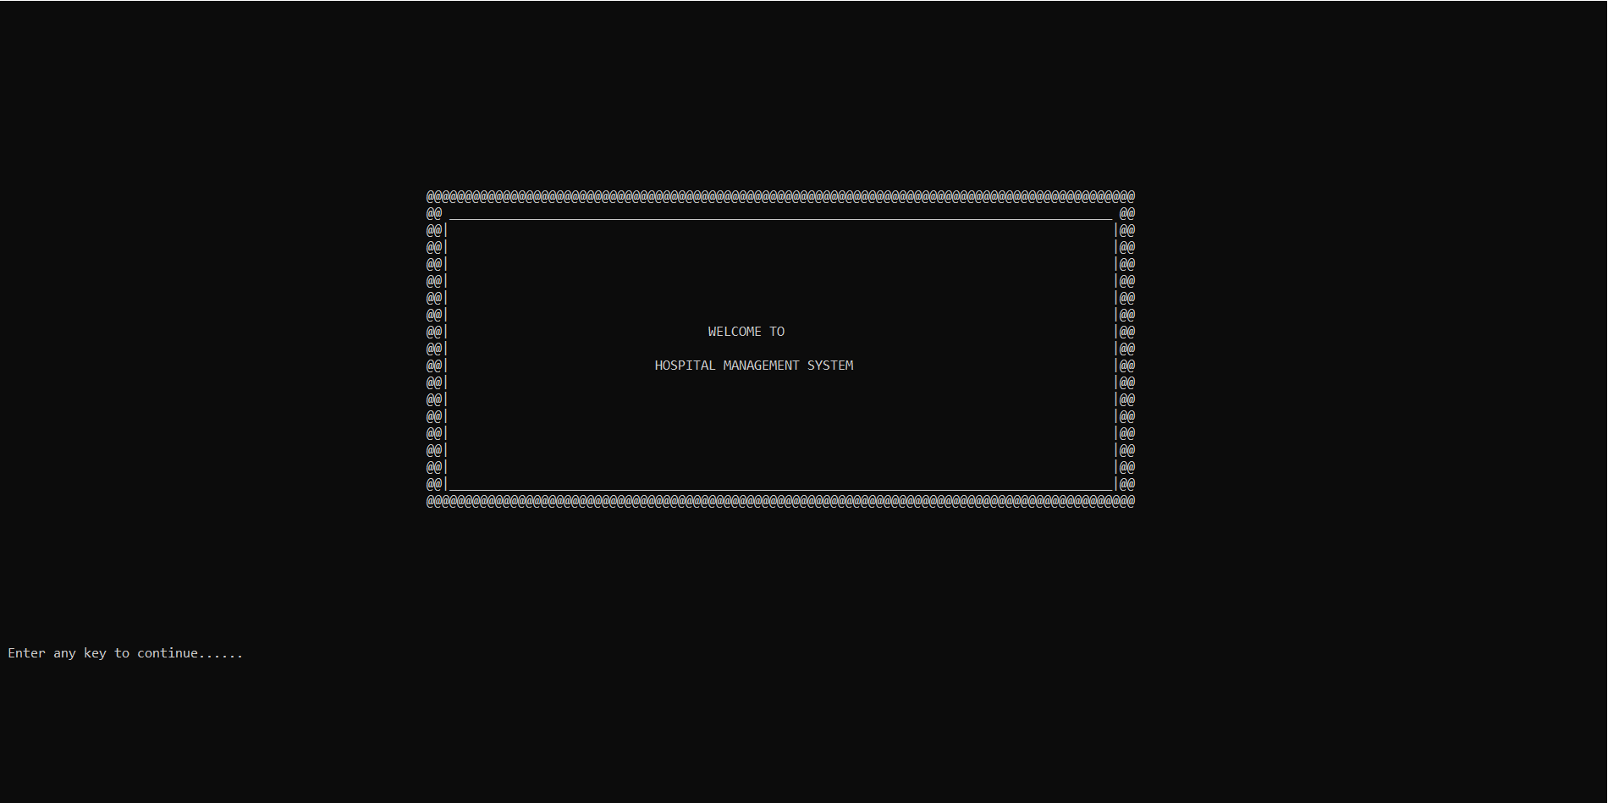

1. SS#2

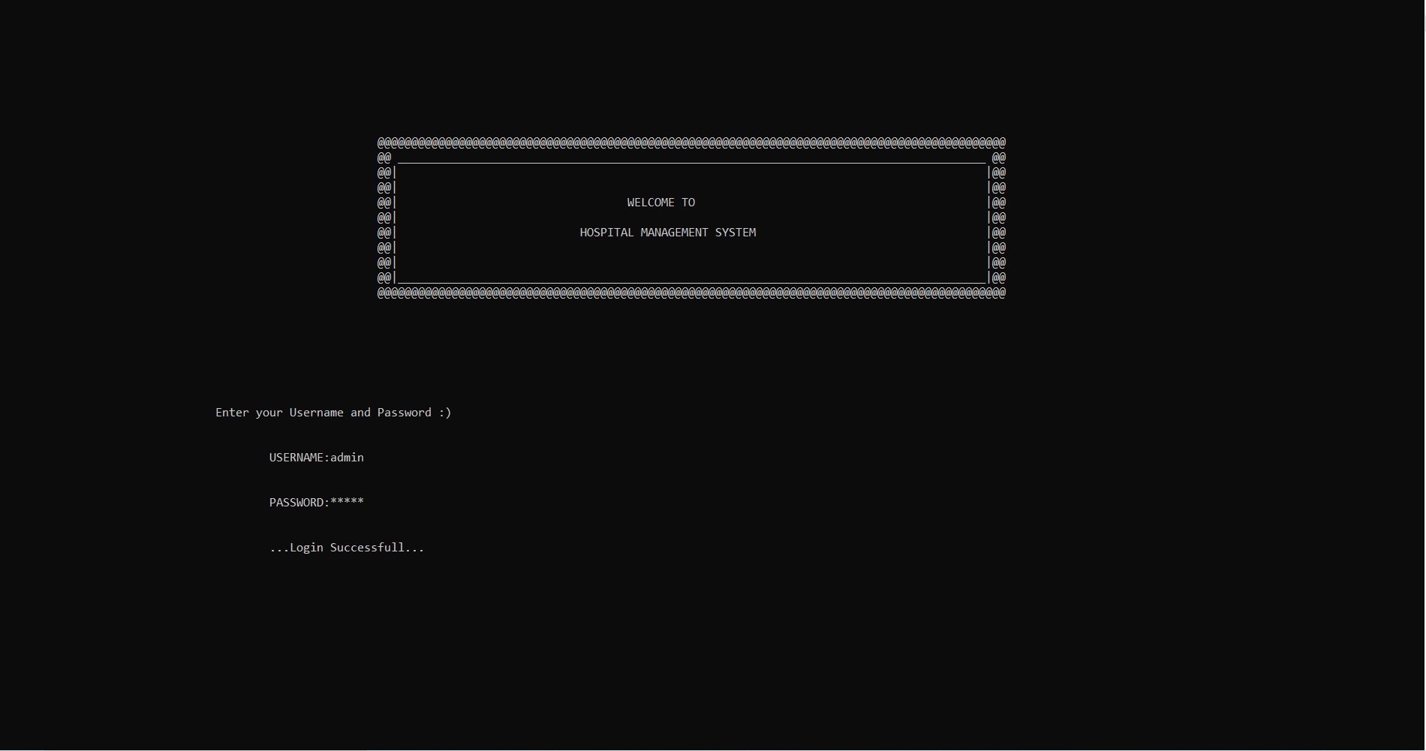

1. SS#3

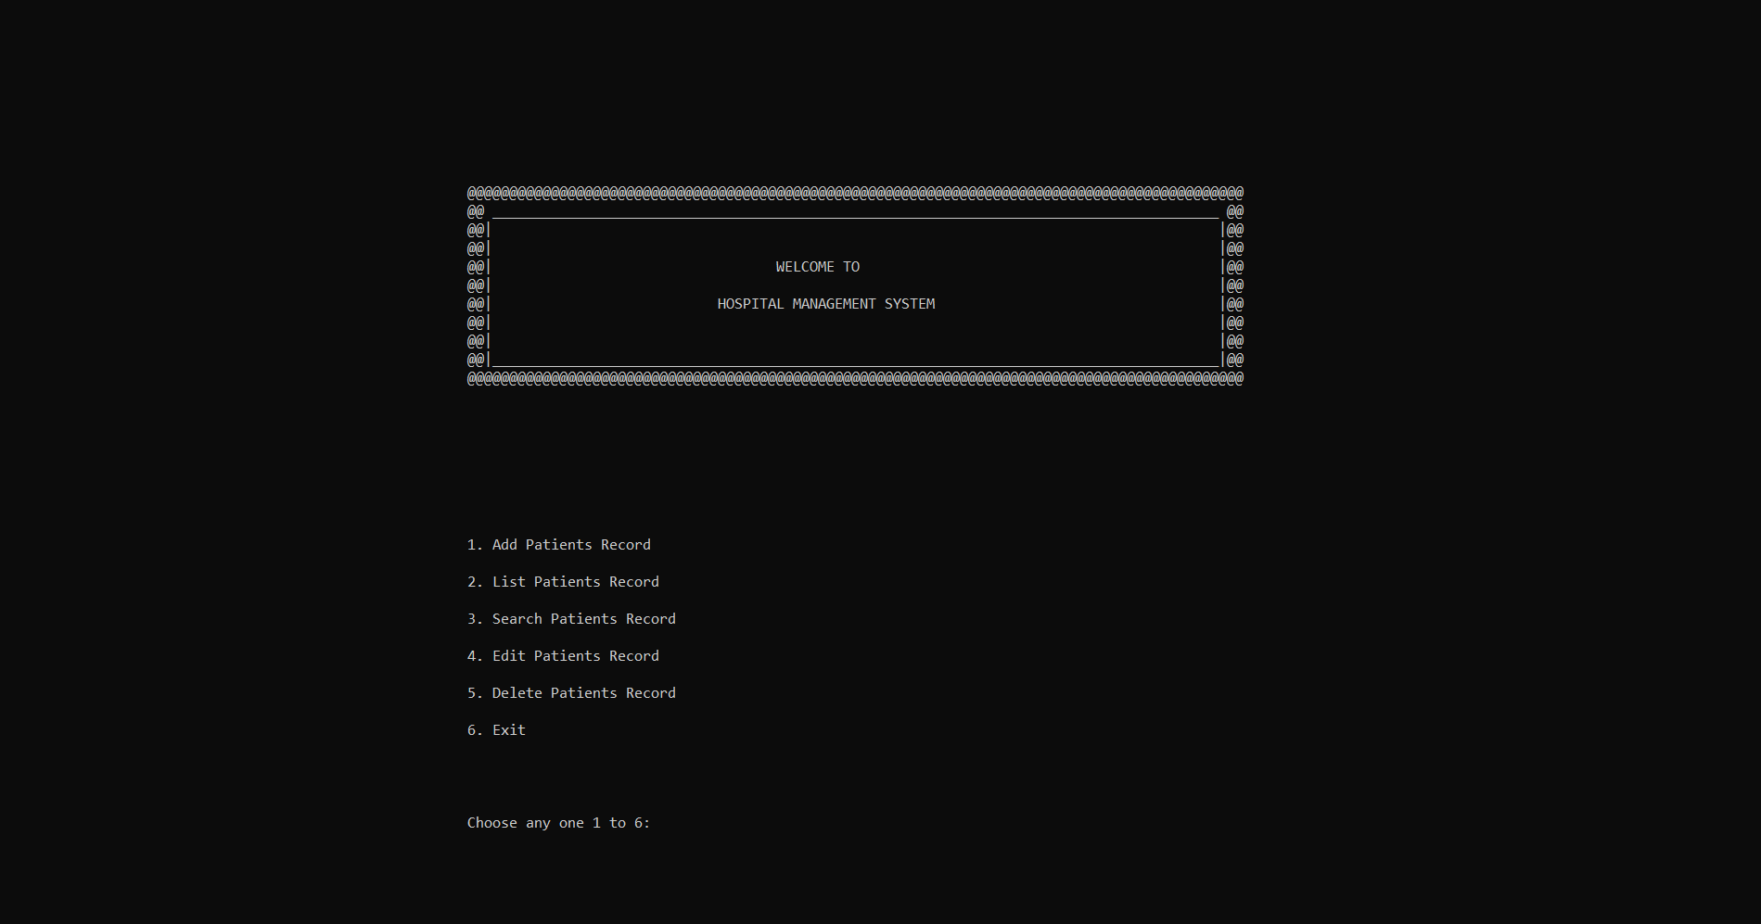

1. SS#4

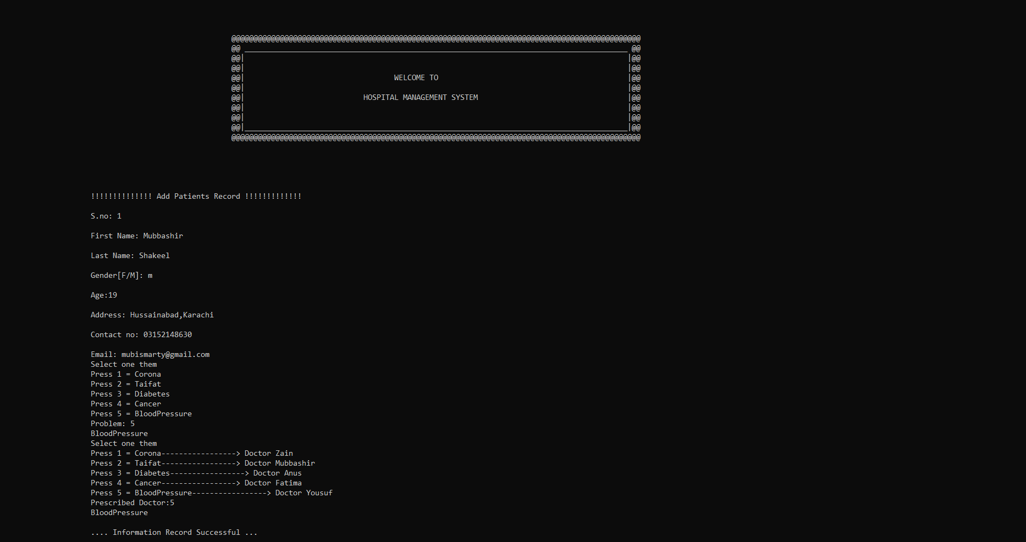

1. SS#5

